# Date: March 6, 2019
# Author: Wei Li, Florence Yan, Ziyu Jin

Sample selection criteria:
- Excluded rows containing missing values in credit history information.
- Excluded rows containing missing values in gender information.
- Excluded rows containing missing values in marriage status information.

Overall descriptive statistics summary of the data set:
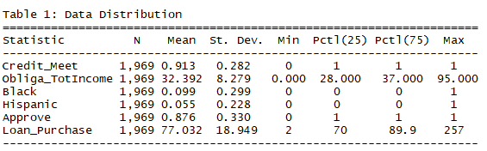

Obligations total income descriptive statistics by race:
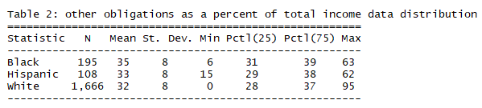

Loan-purchase percentage descriptive statistics by race:
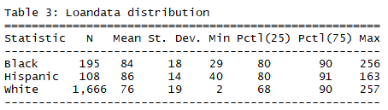

Logit model estimates:

##
## Call:
## glm(formula = Approve ~ Marrige_Status + Credit_Meet + Obliga_TotIncome +
## Black + Hispanic + Gender + Loan_Purchase, family = "binomial",
## data = MLD)
##
## Deviance Residuals:
## Min 1Q Median 3Q Max
## -2.8933 0.2445 0.3128 0.3742 2.3261
##
## Coefficients:
## Estimate Std. Error z value Pr(>|z|)
## (Intercept) 1.381531 0.591656 2.335 0.019542 *
## Marrige_Status1 0.475742 0.192005 2.478 0.013221 *
## Credit_Meet1 3.719269 0.217169 17.126 < 2e-16 ***
## Obliga_TotIncome -0.034074 0.010310 -3.305 0.000950 ***
## Black1 -0.815693 0.240177 -3.396 0.000683 ***
## Hispanic1 -0.900010 0.310585 -2.898 0.003758 **
## Gender1 -0.053947 0.234573 -0.230 0.818107
## Loan_Purchase -0.016812 0.005074 -3.313 0.000922 ***
## ---
## Signif. codes: 0 '***' 0.001 '**' 0.01 '*' 0.05 '.' 0.1 ' ' 1
##
## (Dispersion parameter for binomial family taken to be 1)
##
## Null deviance: 1475.4 on 1968 degrees of freedom
## Residual deviance: 959.4 on 1961 degrees of freedom
## AIC: 975.4
##
## Number of Fisher Scoring iterations: 6

Odds Ratios

## (Intercept) Marrige_Status1 Credit_Meet1 Obliga_TotIncome
## 3.9809925 1.6092076 41.2342404 0.9665001
## Black1 Hispanic1 Gender1 Loan_Purchase
## 0.4423326 0.4065655 0.9474819 0.9833287

Probit Model

##
## Call:
## glm(formula = Approve ~ Marrige_Status + Credit_Meet + Obliga_TotIncome +
## Black + Hispanic + Gender + Loan_Purchase, family = binomial(link = "probit"),
## data = MLD)
##
## Deviance Residuals:
## Min 1Q Median 3Q Max
## -2.9694 0.2361 0.3119 0.3762 2.2711
##
## Coefficients:
## Estimate Std. Error z value Pr(>|z|)
## (Intercept) 0.566210 0.309521 1.829 0.067353 .
## Marrige_Status1 0.237894 0.096134 2.475 0.013338 *
## Credit_Meet1 2.142459 0.121264 17.668 < 2e-16 ***
## Obliga_TotIncome -0.016400 0.005344 -3.069 0.002148 **
## Black1 -0.425865 0.126958 -3.354 0.000795 ***
## Hispanic1 -0.463475 0.163507 -2.835 0.004588 **
## Gender1 -0.033267 0.117944 -0.282 0.777896
## Loan_Purchase -0.008409 0.002590 -3.247 0.001166 **
## ---
## Signif. codes: 0 '***' 0.001 '**' 0.01 '*' 0.05 '.' 0.1 ' ' 1
##
## (Dispersion parameter for binomial family taken to be 1)
##
## Null deviance: 1475.43 on 1968 degrees of freedom
## Residual deviance: 958.84 on 1961 degrees of freedom
## AIC: 974.84
##
## Number of Fisher Scoring iterations: 6
Observations:
Signs of estimates in Logit and Probit models match. Negative signs on OBRAT, black, Hispanic and LOANPRC are expected.

